

**Mawlana Bhashani Science And Technology University**

**Lab-Report**

Lab Report No: 02

Lab Report Name: Linux assignment.

Group member ID: IT-17013 and IT-18013

Date of Performance: 25-12-2020

Date of Submission: 27-12-2020

Name: Anjom Nour Anika

ID: IT-18013.

3rd Year 2nd Semester

Session: 2017-2018

Dept. of ICT, MBSTU

**Submitted by Submitted To**

Nazrul Islam

Assistant Professor

Dept. of ICT

MBSTU.

*}*

**Network Configuration, Routing Table and Virtual Interfaces**

1. Introduction:

Solution:

Each device connected to a computer network that uses the Internet Protocol for communication is assigned a numerical label, an Internet Protocol address, or IP address for short. An IP address identifies the device an establishes a path to it.

But not all IP addresses can be reached through the public internet, and **192.168.1.1** is among them. This default IP address of most Linksys routers is one of 65,536 IP addresses in the 16-bit block of the private IPv4 address space, which includes addresses from **192.168.0.0** to **192.168.255.255**.Private IP addresses are used for local area networks (LANs), and they were defined in an effort to delay IPv4 address exhaustion. Because private IP addresses can be used without approval from a regional Internet registry, they allow anyone from individual home users to organizations to readily deploy internet-connected devices using Network Address Translation (NAT), a method of assigning a public address to a computer inside a private network.Manufacturers of home routers use private IP addresses, including **192.168.1.1**, as the default gateway, allowing users to type http://192.168.1.1 into a web browser to access the router admin panel and change router settings.

2.Find IP and MAC:

Write down the IP and MAC address of your computer?

Solution:*5*

3. Routing Table basics:

Solution: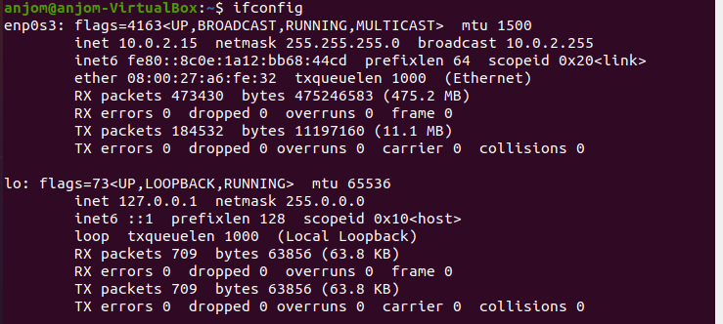

Enter the command: "$ netstat -r" to print your computers routing table.

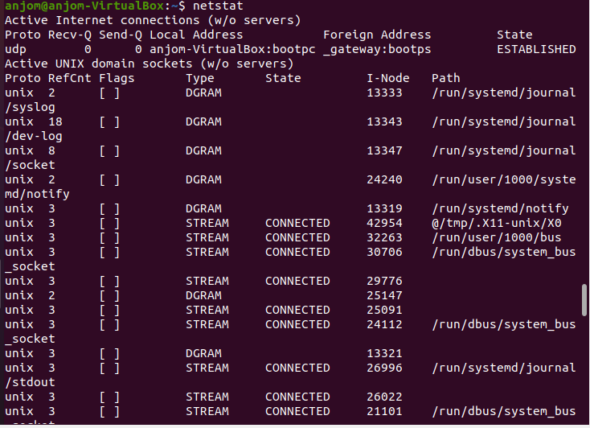

Enter the command: "$ netstat -nr" to print your computers routing table.

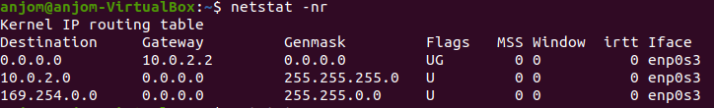

The –n option makes **netstat** print addresses as dotted quad IP numbers rather than the symbolic host and network names. This option is especially useful when you want to avoid address lookups over the network (e.g., to a DNS or NIS server).

The second column of **netstat** 's output shows the gateway to which the routing entry points. If no gateway is used, an asterisk is printed instead. The third column shows the “generality” of the route.

**4) Virtual Interfaces**:

a) Create a new virtual interface with following IP address, 192.168.2.32 and netmask 255.255.255.0 then check to see if the interface was created successfully?

b) Now, you need to set up a route for this interface so that your computer can see it. Otherwise,

everyone else on the network will be able to reach the new interface except you. Issue the needed command, then issue the "$ netstat -r" command and check if the route to your added interface is visible.

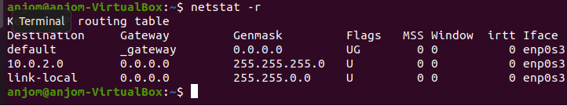

c) Next remove the route for this interface.

**5) Add a New Network:**

a) Enter the command needed to add another network with the same values as your primary network meaning:

b) Assign the default gateway for your newly added network(tip the same default gateway as your primary network), (Your default gateway address).

c) Look for your newly added network in your routing table by issuing the “$ netstar -r” command. You should now have a double setup of your primary network in the table.

d) Now, remove your changes meaning the double routing table setup for your primary network. First issue the command needed to delete your newly added route then issue the command to delete your newly added default gateway.